# Homework: Data Modeling and E/R Diagrams

This document defines the homework assignments from the ["Databases" Course @ Software University](https://softuni.bg/trainings/20/Databases-Feb-2015). Please submit as homework a single zip / rar / 7z archive holding the solutions (source code) of all below described problems.

## Create the following database diagram in SQL Server.

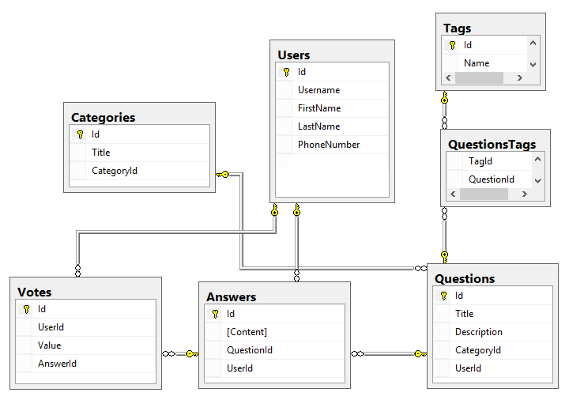

There are **two missing relationships**. Your task is to find the missing relationships between tables, then create the following database diagram in SQL Server with missing relationships.

You should submit a screenshot of database diagram with details info about columns (column name, data type and allow nulls) as a part of your homework.

## Fill some sample data in the tables with SSMS.

You task is to fill sample data in tables from the previous task.

You should submit the database backup file as a part of your homework.

## Create a data model for typical university in SQL Server.

Typical universities have: faculties, departments, professors, students, courses, etc. Faculties have name and could have several departments. Each department has name, professors and courses. Each professor has name, a set of titles (Ph. D, academician, senior assistant, etc.) and a set of courses. Each course consists of several students. Each student belongs to some faculty and to several of the courses.

You should submit the database backup file as a part of your homework.

## Create the same data model in MySQL.

Your task is to create the same data model for typical university from the previous task in MySQL.

You should submit the SQL scripts of the database as a part of your homework.

## *Design a database schema to store the dictionary in SQL Server.

We should design a multilingual dictionary. We have a set of words in the dictionary. Each word can be in some language and can have synonyms and explanations in the same language and translation words and explanations in several other languages. The synonyms and translation words are sets of words from the dictionary. The explanations are textual descriptions. Add support in the previous database for storing antonym pairs. Add support for storing part-of-speech information (e.g. verb, noun, adjective…). Add support for storing hypernym / hyponym chains (e.g. tree 🡪 oak, pine, walnut-tree…).

You should submit the database backup file as a part of your homework.